**TASK 1**

**Basics of Git:**

1. git init: Initialize a new Git repository.

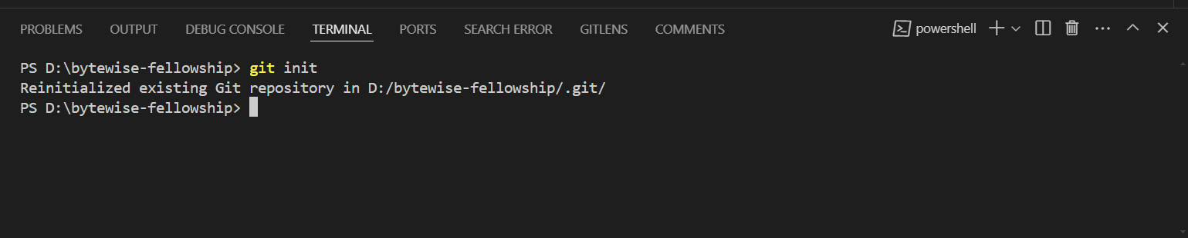

1. git add: Add files to the staging area.

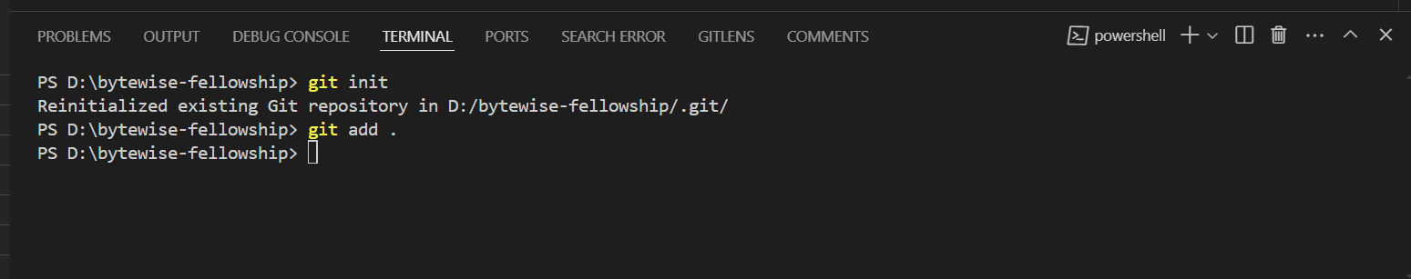

1. git commit: Commit your changes to the repository.

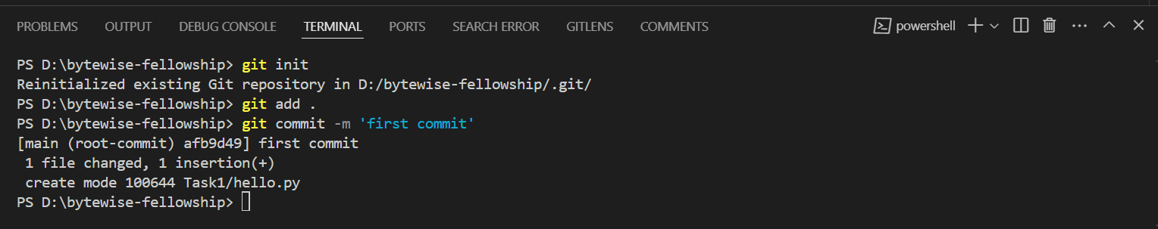

1. git push: upload local repository content to a remote repository

